Abstract

This report provides an overview of the information systems used by KFC, a global fast-food chain. The report starts with an introduction to KFC and its background. It then delves into the different types of information systems used by KFC, including their point of sale (POS) system, supply chain management system, and customer relationship management (CRM) system. The report also highlights the benefits of these information systems, such as increased efficiency, better inventory management, and improved customer experience. Additionally, the report discusses the challenges that KFC faces in implementing and maintaining these information systems. The conclusion summarizes the main findings of the report and provides recommendations for KFC to enhance their information systems.

Acknowledgement

We would like to express our gratitude to everyone who has contributed to the successful completion of this report. Firstly, we would like to thank our teachers for their guidance and support throughout the research and writing process. Their constructive feedback and insightful suggestions have been invaluable in shaping this report.
We would also like to extend our appreciation to our seniors who generously shared their time and provided us with the necessary information to conduct this study. Their willingness to participate and their openness in sharing their experiences and insights were instrumental in the development of this report.
Furthermore, we would like to thank our families and friends for their unwavering support, encouragement, and understanding throughout this challenging process.
Finally, we would like to express our appreciation to all the authors of the relevant literature and resources that have contributed to the development of this report. Their knowledge and expertise have been invaluable in guiding my research and writing.
Once again, we express our sincere appreciation to everyone who has contributed to the completion of this report.

Table Of Contents
Abstract 2
Acknowledgement 3
1. Introduction To Kfc & It’s Information Systems 5
2. Definition Of Information Systems 6
2.1. Operation Support Information Systems 7
2.1.1. Point Of Sale (Pos) System 7
2.1.2. Inventory Management System 7
2.2. Knowledge Support Information Systems 7
2.2.1. Expert Systems 7
2.3. Management Support Information System 8
2.3.1. Executive Dashboard 8
2.3.2. Decision Support System 8
3. Information Systems & It’s Components 9
4. Security Threats And Machanisms To Prevent Them 11
4.1 Security Threats 11
4.1.1 Point Of Sale (Pos) System 11
4.1.2 Inventory Management System 11
4.1.3 Human Resources Management System 11
4.1.4 Customer Relationship Management System 11
4.2 Security Machanisms 12
4.2.1 Point Of Sale (Pos) System 12
4.2.2 Inventory Management System 12
4.2.3 Human Resources Management System 12
4.2.4 Customer Relationship Management System 12
5 Conclusion 13
6 References 14
7 Appendices 15
7.1. Workload Matrix 15
7.2. Meeting Agenda & Minutes 16

INTRODUCTION TO KFC & IT’S INFORMATION SYSTEMS


KFC (Kentucky Fried Chicken) is a global fast-food chain that is known for its fried chicken. It was founded in 1952 by Colonel Harland Sanders in Louisville, Kentucky, and has since grown to become one of the world's largest restaurant chains. Today, KFC has more than 24,000 locations in over 145 countries, serving millions of customers each day.
Operational support systems are used to manage day-to-day business activities, such as sales transactions and inventory management, Management support systems are designed to support managerial decision-making and planning activities and knowledge support systems are designed to support the knowledge management activities of the organization.
Figure 1 - KFC
KFC's information systems infrastructure plays a critical role in supporting its business operations and decision-making processes. By utilizing a variety of operational, management, and knowledge support systems, KFC can effectively manage its global operations, monitor performance, and provide a seamless customer experience.
To keep up with its vast operations and customer base, KFC utilizes a range of information systems to manage its business operations. These systems include point-of-sale (POS) systems, inventory management systems, supply chain management systems, and customer relationship management systems. Through the use of these systems, KFC is able to efficiently manage its operations, optimize its supply chain, monitor customer preferences, and provide a seamless experience to its customers. Additionally, KFC has also incorporated digital technologies to enhance its customer engagement and improve its operations.

DEFINITION OF INFORMATION SYSTEMS
Figure 2 - Information Systems
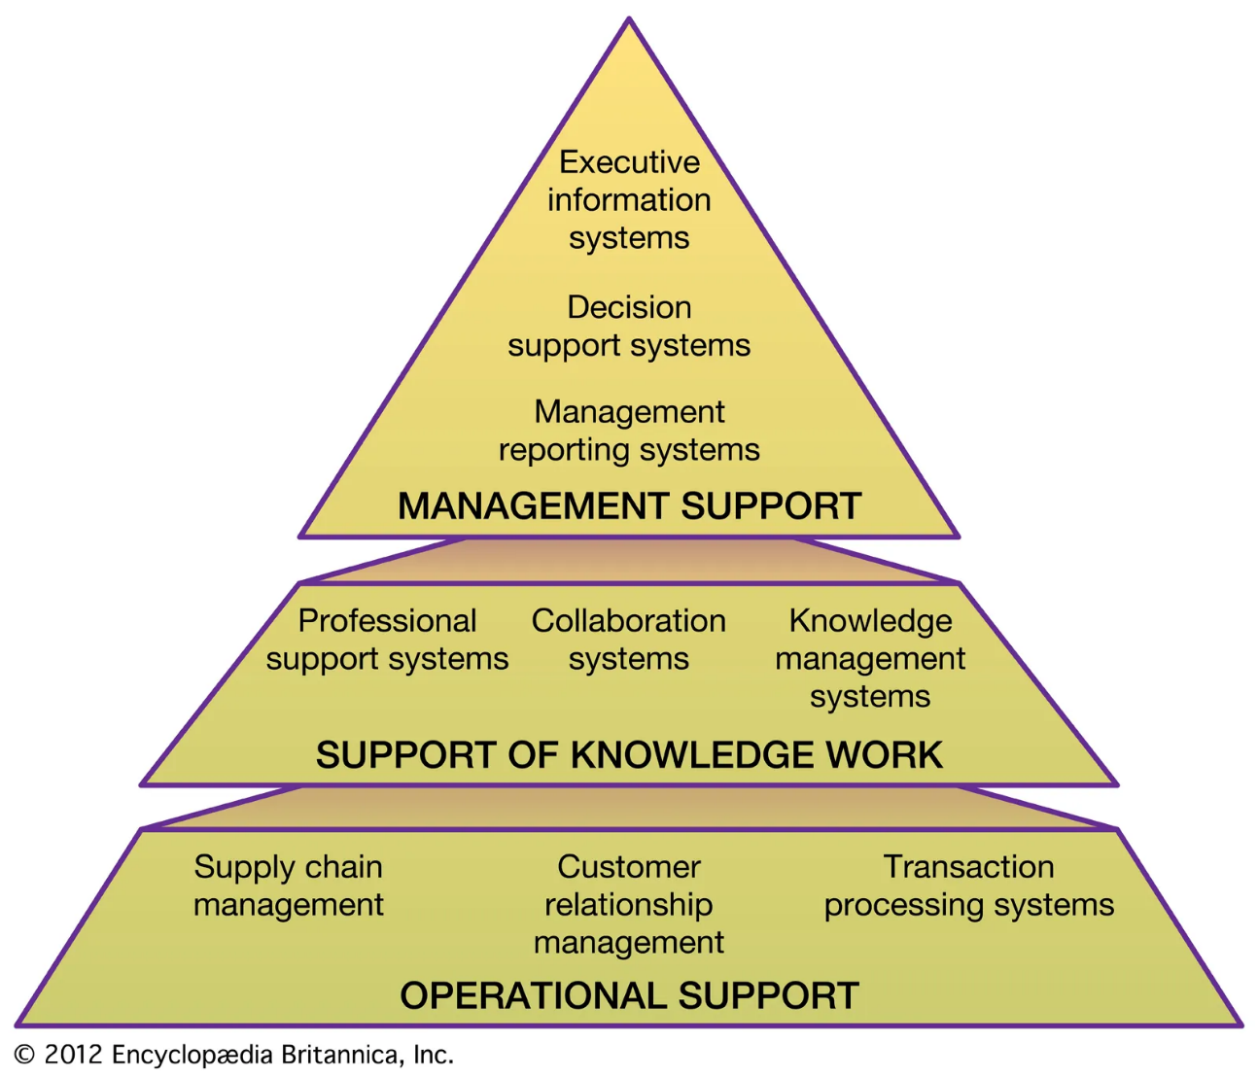
An organization's information systems consist of a network of interdependent parts that collaborate to gather, process, preserve, and distribute information and data. These systems use a combination of hardware, software, data, and people to support business operations and decision-making processes. Information systems are critical to the success of modern organizations, providing the necessary tools to manage and analyze vast amounts of data, streamline processes, and improve communication and collaboration across the organization. They play a key role in enabling businesses to adapt to changing market conditions, stay competitive, and make informed decisions. In recent years, advancements in technology have led to the development of new types of information systems, including cloud-based systems, mobile applications, and artificial intelligence-powered systems, further increasing their value to organizations of all sizes and industries.

Operation Support Information Systems

Operational Support Information System is a type of information system that supports day-to-day operations. OSIS provides information to support routine, repetitive, and structured decisions. Examples of Operational Support Information System used in KFC are:
- Point of Sale (POS) System
- Inventory Management System

Point of Sale (POS) System
A POS system is used to process transactions at the restaurant. At KFC, a POS system could be used to process orders, calculate taxes, and generate receipts.

Inventory Management System
An inventory management system is used to manage the inventory levels of raw materials, finished goods, and supplies. At KFC, an inventory management system could be used to track the inventory levels of chicken, buns, sauces, and other ingredients.

Knowledge Support Information Systems

Knowledge Support Information System is a type of information system that helps organizations create, store, and disseminate knowledge. It also allows employees to access the information they need to perform their jobs more efficiently. Examples of Knowledge Support Information System used in KFC are:
- Expert System

Expert Systems
This system is a computer program that takes off the decision-making ability of a human expert. At KFC, an expert system could be used to recommend the best menu items for customers based on their preferences and to store recipes, cooking techniques, and best practices that are used to prepare KFC's signature dishes.. This also helps organizations manage their knowledge assets.

Management Support Information System

Management Support Information System is a type of information system that provides information to top-level management to support strategic decision-making. It provides timely, accurate, and relevant information that can help executives and managers make informed decisions. Examples of Management Support Information System used in KFC are:
- Executive Dashboard
- Decision Support System

Executive Dashboard
An executive dashboard is a visual representation of key performance indicators used to monitor the overall performance of the organization. At KFC, an executive dashboard could display sales, revenue, customer satisfaction, and employee productivity.

Decision Support System
A Decision support system is a computer-based system that helps decision-makers analyze data and make informed decisions. At KFC, a DSS could be used to determine which products to launch in new markets, what prices to set, and which marketing strategies to use.

INFORMATION SYSTEMS & IT’S COMPONENTS

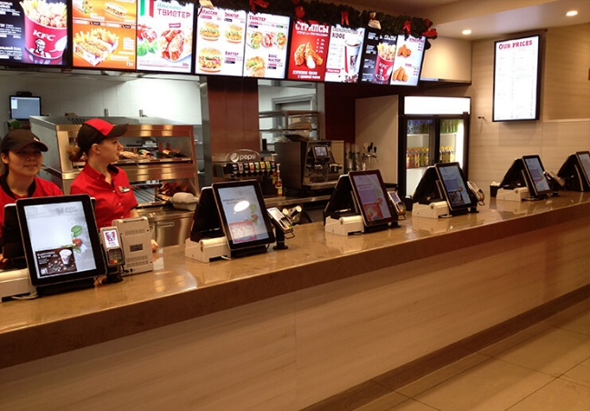
Hardware:
Figure 3 - Hardware
The hardware components of the POS system include a terminal, a cash drawer, a receipt printer, and a card reader. The terminal is the main device that allows employees to input orders and process payments. The cash drawer is used to store cash received from customers. The receipt printer is used to print receipts for customers. The card reader is used to read payment card information.

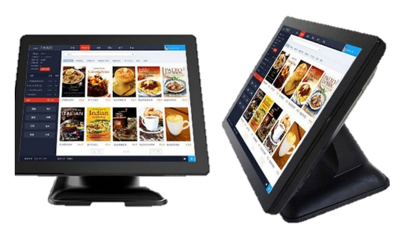
Software:
Figure 4 - Software
The POS software is the application that runs on the terminal and processes customer orders and payments. The software includes a graphical user interface (GUI) that allows employees to input orders, apply discounts and coupons, and process payments. The software also integrates with the kitchen system, which sends order details to the kitchen staff.

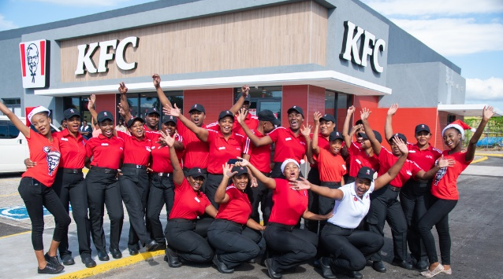
People:
Figure 5 - People
The people component of the POS system includes the employees who use the system, including cashiers, servers, and kitchen staff. Cashiers and servers use the system to input customer orders and process payments, while kitchen staff use the system to receive and fulfill customer orders.

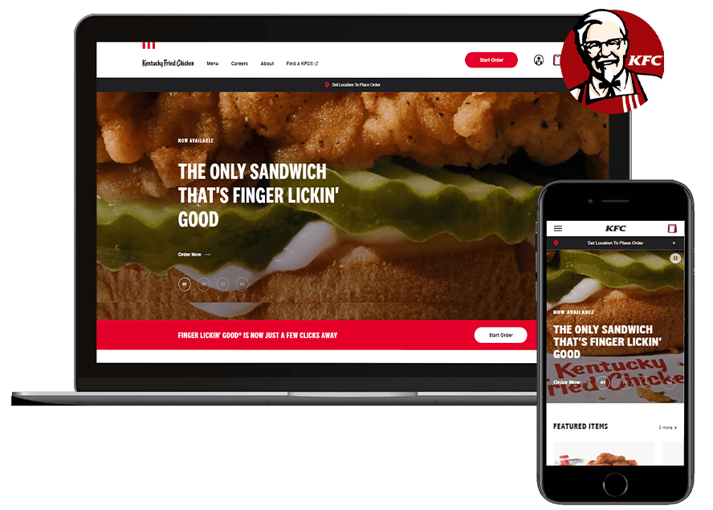
Process:
Figure 6 - Process
The process component of the POS system includes the procedures employees follow when using the system. The process begins when a customer places an order, which is entered into the POS system by a cashier or server. The system then sends the order details to the kitchen staff, who prepare and cook the food. Once the food is ready, the kitchen staff mark the order as complete in the system, and the cashier or server retrieves the food and delivers it to the customer. Finally, the system processes the payment and generates a receipt for the customer.

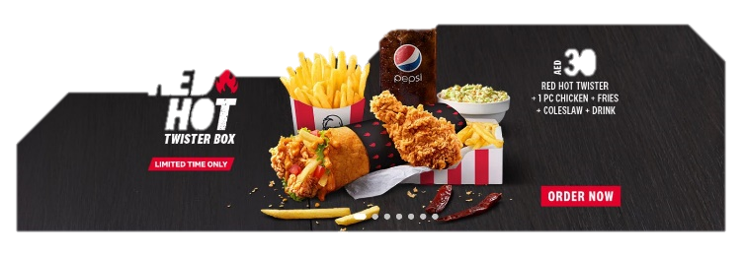
Data:
Figure 7 - Data
The data component of the POS system includes customer order details, payment information, and sales data. The system records each customer order and stores the order details, including the items ordered, any discounts or coupons applied, and the payment method. The system also records sales data, such as the total number of orders processed, and the total amount of sales revenue generated. This data is used by KFC to analyze sales trends, forecast demand, and identify areas for improvement.

SECURITY THREATS AND MACHANISMS TO PREVENT THEM

Security Threats

There are several security threats that could potentially affect the information systems used by KFC. Here are a few examples:
- Point of sale system
- Inventory management system
- Human Resources Management System
- Customer Relationship Management System

Point of Sale (POS) System
The POS system is a prime target for cyber criminals who seek to steal payment card data. Attackers may attempt to install malware on the POS system to intercept payment card data as it is being processed. This can lead to significant financial losses and damage to KFC's reputation.

Inventory Management System
If the inventory management system is not properly secured, it may be vulnerable to unauthorized access or manipulation. Attackers could potentially modify inventory levels or ingredient lists, which could lead to incorrect orders or shortages.

Human Resources Management System
The human resources management system contains sensitive information about KFC's employees, including personal data and financial information. If this system is not properly secured, attackers could potentially gain access to this data and use it for identity theft or financial fraud.

Customer Relationship Management System
The customer relationship management system contains valuable customer data, such as contact information and purchasing habits. If this system is compromised, attackers could potentially steal this data and use it for targeted phishing or other types of fraud.

  - Security Machanisms

Here are a few mechanisms that KFC can use to mitigate the security threats mentioned earlier:
- Point of sale system
- Inventory management system
- Human Resources Management System
- Customer Relationship Management System

Point of Sale (POS) System
To mitigate the threat of payment card data theft, KFC can implement end-to-end encryption to protect payment data as it is transmitted from the POS system to the payment processor. KFC can also implement two-factor authentication for access to the POS system, and regularly monitor the system for suspicious activity.

Inventory Management System
To prevent unauthorized access to the inventory management system, KFC can implement strong access controls, such as multi-factor authentication and role-based access control. KFC can also regularly review system logs to detect any suspicious activity or unauthorized access attempts.

Human Resources Management System
To prevent unauthorized access to the human resources management system, KFC can implement strong access controls, such as multi-factor authentication and role-based access control. KFC can also regularly review system logs to detect any suspicious activity or unauthorized access attempts. Additionally, KFC can implement data loss prevention technologies to prevent the unauthorized transfer of sensitive data.

Customer Relationship Management System
To protect the customer relationship management system, KFC can implement strong access controls and encryption for all data in transit and at rest. KFC can also regularly review system logs to detect any suspicious activity or unauthorized access attempts. Additionally, KFC can implement two-factor authentication for customer accounts, and educate customers on how to protect their personal information.

Conclusion

References

Appendices

Workload matrix

Meeting Agenda & Minutes

